Laura Summervill CIS 241 – Final Project

Documentation File

All files are saved in folder (CIS 241 – Final Project).

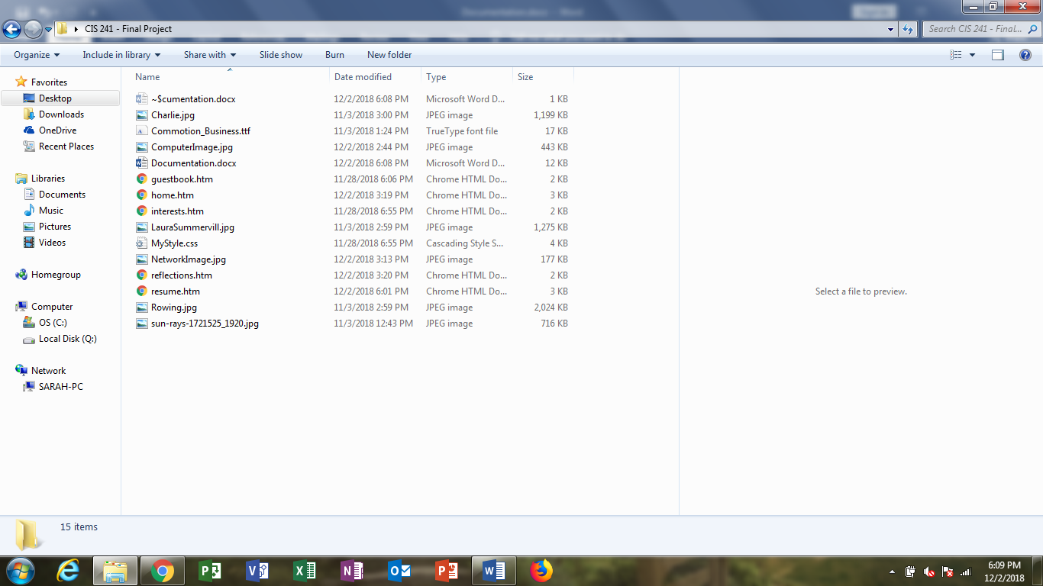

Home Page: (home.htm)

Describes general overview of professional and personal interests.

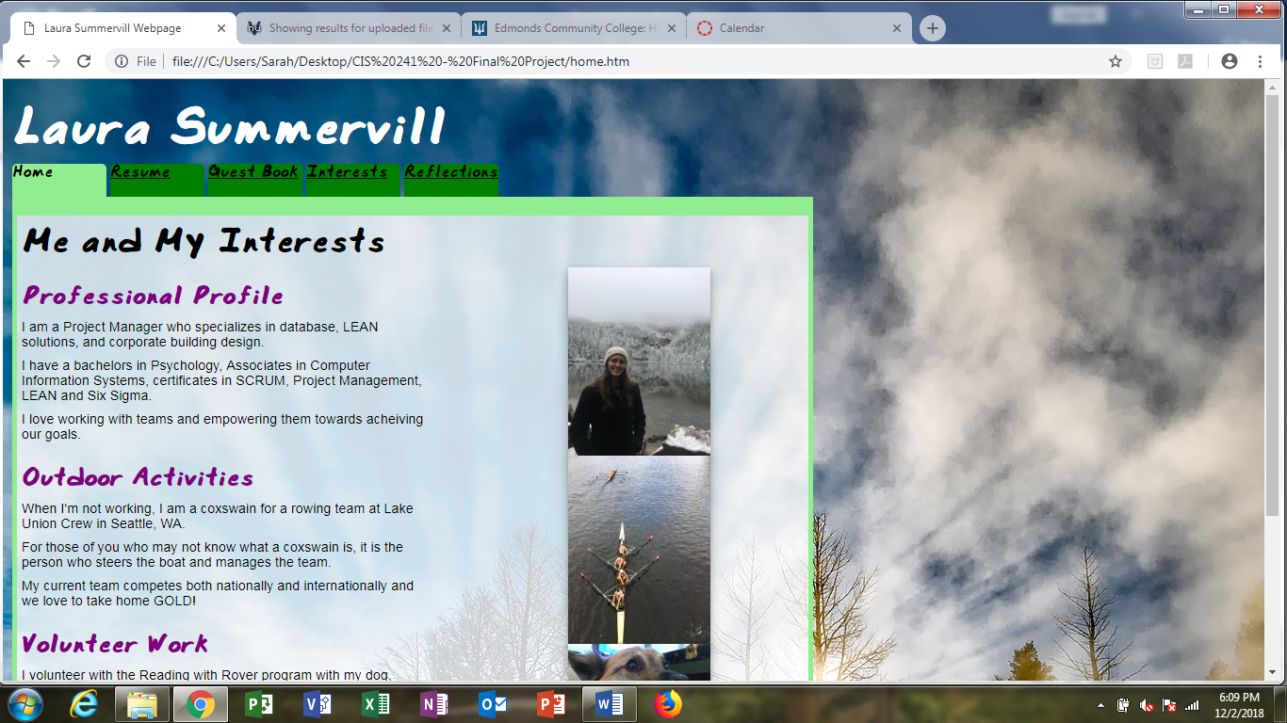

Resume Page: (Resume.htm)

Details resume and professional profile.

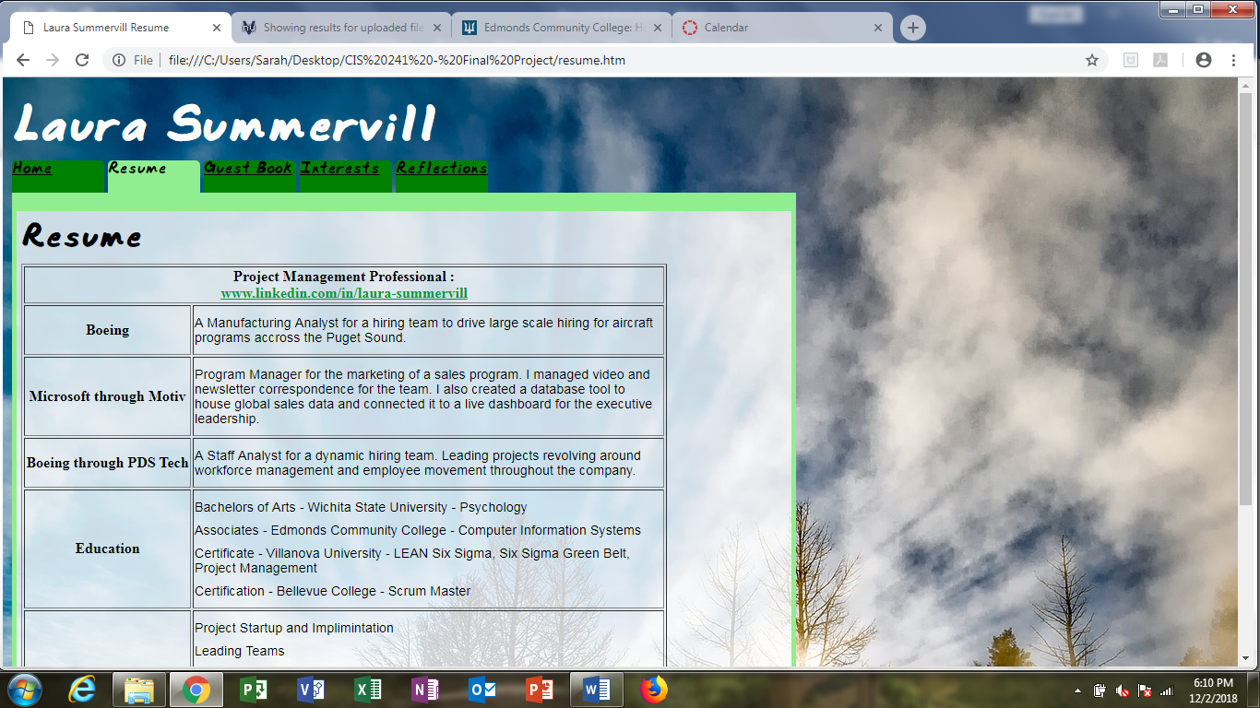

Guest Book Page: (guestbook.htm)

Textboxes and dropdowns for website guests to sign in.

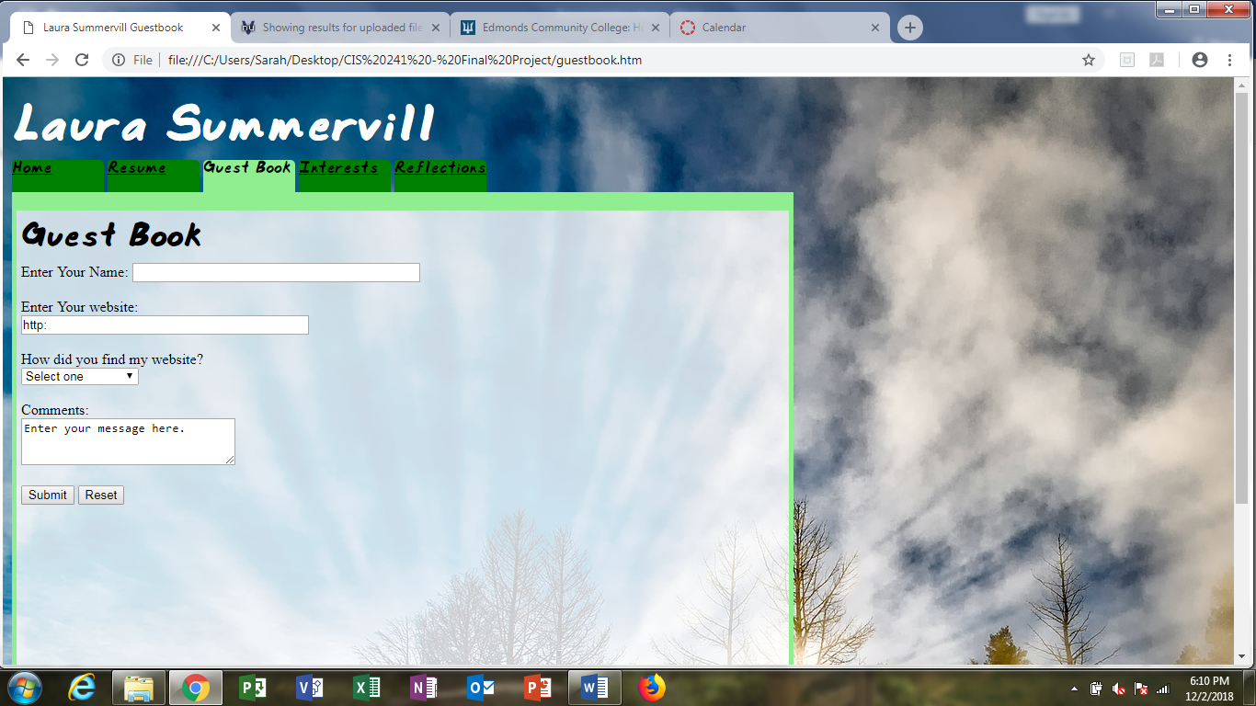

Interests Page: (interests.htm)

Gives links to interesting websites.

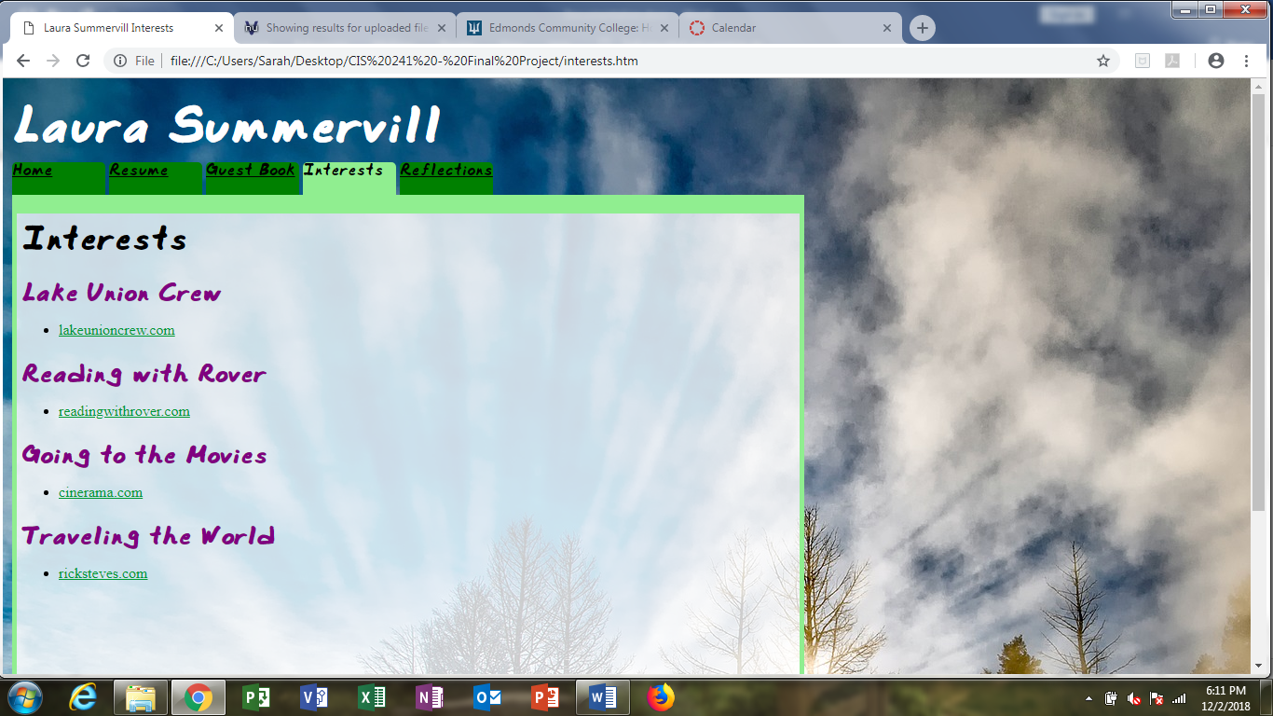

Reflections Page: (reflections.htm)

An overview of the EDCC CIS program.

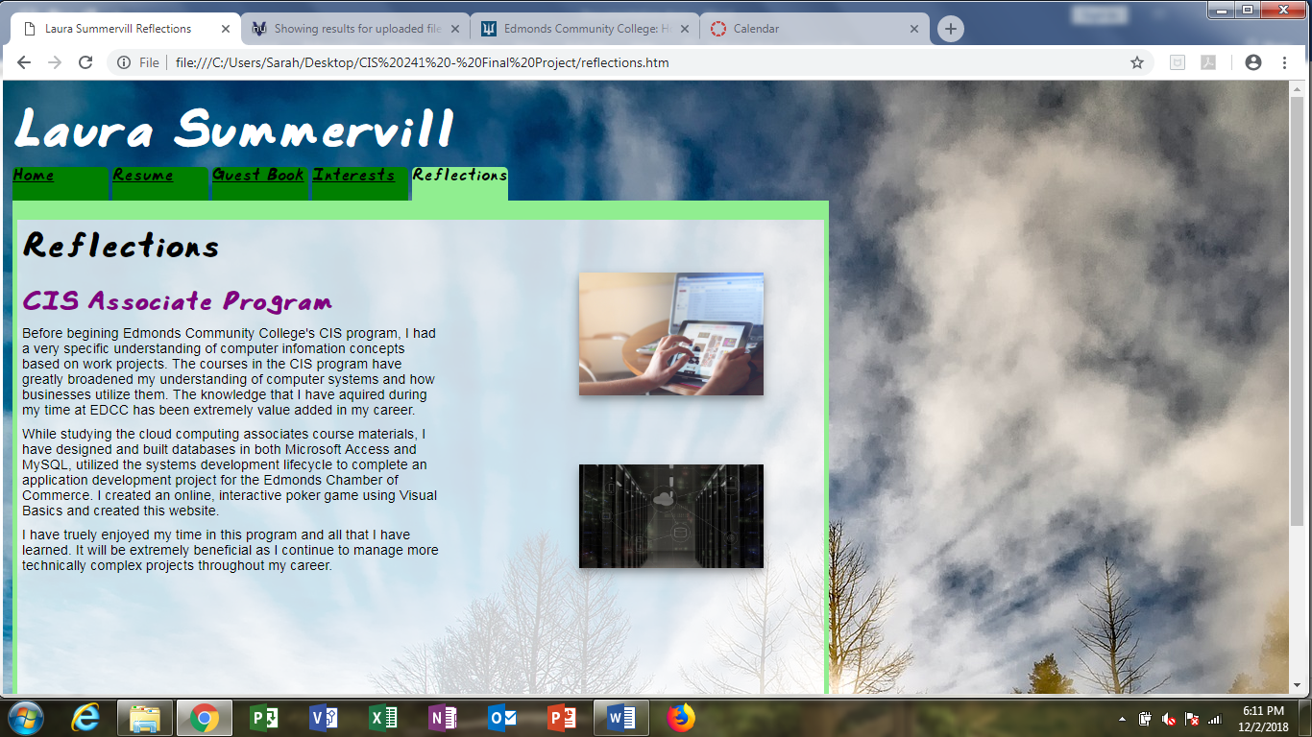

Style Sheet (MyStyle.css):

Cascading style sheet for all tabs of the website.

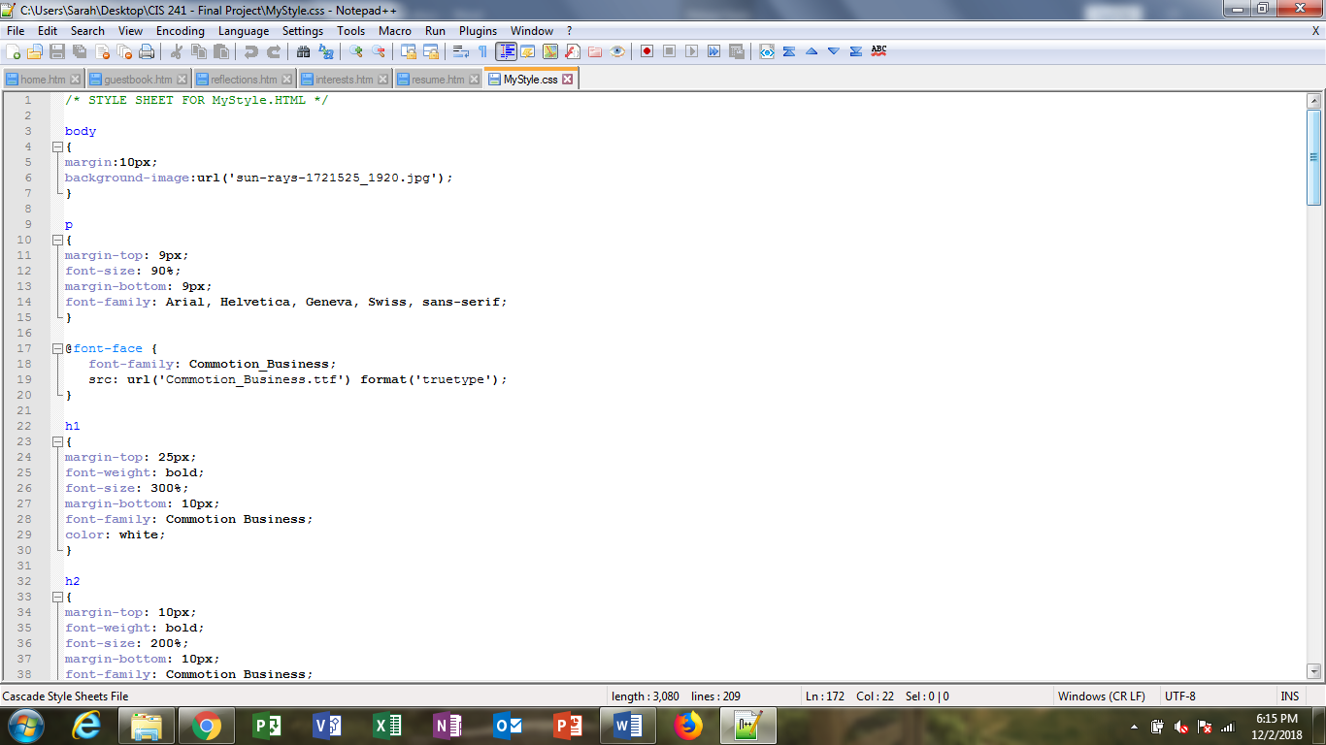

Text Style (Commotion_Business.ttf):

Text style for all headers of the website.

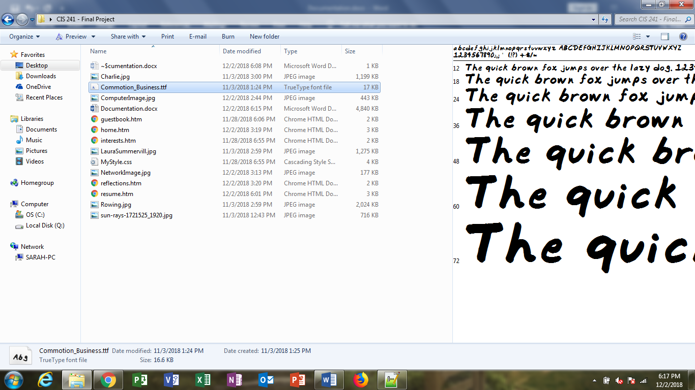

JPG Files:

Images shown throughout the website.

